CO₂-rich xenoliths at Mt. Vulture volcano (southern Italy): new constraints on the volcano plumbing system
Carnevale G.^{1,2*}, Caracausi A. ^{2,3}, Coltorti M. ⁴, Faccini B. ⁴, Marras G. ⁵, Paternoster M. ^{2,6}, Rotolo S.G. ^{1,2}, Stagno V. ^{5,2}, Zanon V. ⁷, Zummo F. ⁶
¹ Dipartimento di Scienze della Terra e del Mare, Università degli Studi di Palermo, Palermo, Italy; ² Istituto Nazionale di Geofisica e Vulcanologia, Palermo, Italy; ³ Departamento de Geología, Universidad de Salamanca, Salamanca, Spain; ⁴ Dipartimento di Fisica e Scienze della Terra, Università di Ferrara, Ferrara, Italy; ⁵ Dipartimento di Scienze della Terra, Sapienza Università di Roma, Rome, Italy; ⁶ Dipartimento di Scienze, Università della Basilicata, Potenza, Italy; ⁷ Instituto de Investigação em Vulcanologia e Avaliação de Riscos, Universidade dos Açores, Ponta Delgada, Portugal.
* e-mail: gabriele.carnevale@unipa.it

This study provides new mineral chemistry data together with micro-thermometric measurements on fluid inclusions (FIs) hosted in ultramafic xenoliths (lherzolite, wehrlite, and dunite) brought to the surface by the last Mt. Vulture volcano activity (140 ka; southern Italy), and fed by melilitite-carbonatite magmas.
Mantle xenoliths were collected from a compact, fine-grained, carbonate-dominated matrix in an ash-tuff deposit (Carnevale et al., 2022). They are rounded, with an average diameter of 4-5 cm (wehrlite and dunite) and a maximum of 10 cm (lherzolite). The lherzolite is fine- to medium-grained (0.5-1 mm), the wehrlite and dunite are medium- to coarse-grained (2-5 mm). The texture is protogranular, except for the dunite which shows a transitional texture between porphyroclastic and tabular equigranular. Olivine usually shows undulose extinction and intracrystalline deformation structures. Olivine shows an almost constant chemical composition all across the crystal (e.g. Fo₈₉₋₉₀). Orthopyroxene is exclusively found in lherzolite and its composition shows a high proportion of enstatite (En₈₆₋₈₇) compared to wollastonite (Wo₂₋₃) and ferrosilite (Fs₁₀₋₁₁). The composition of clinopyroxene (Wo₄₂₋₄₄, En4₉₋₅₂, Fs₅₋₇) is more variable than the coexisting olivine and orthopyroxene. It shows a wider range of Mg# (0.88-0.91) in wehrlite compared to the almost constant Mg# (0.88) of the lherzolite. Thus, petrographic evidences and mineralogical compositions of Mt. Vulture xenoliths are consistent with an origin in the upper mantle.
FIs are generally rounded (2-10 μm in diameter) with re-equilibration features, such as (i) the presence of dark halos (Bodnar, 2003), and (ii) stretched shapes (Figure 1). No primary FIs were found, and clinopyroxene is the main host for secondary FIs (i.e. trapped after the crystal growth). In all studied xenoliths, FIs are CO₂-dominated with melting temperatures (Tm) ranging between -56.5 and -57.0 °C (± 0.1 °C), and with variable homogenisation temperatures from the vapour to the liquid phase (Th_{L}). The equilibrium temperature calculated by geothermometric estimates ranges from 1039 °C (± 36 °C) to 1142 °C (± 15 °C), and entrapment pressures of FIs with post-trapping re-equilibration correspond to the local crust-mantle boundary (32 km depth), and to a shallow reservoir located at 12-14 km depth. These results contribute to constrain the origin of these xenoliths and the depth of storage of magmas erupted from Mt. Vulture.
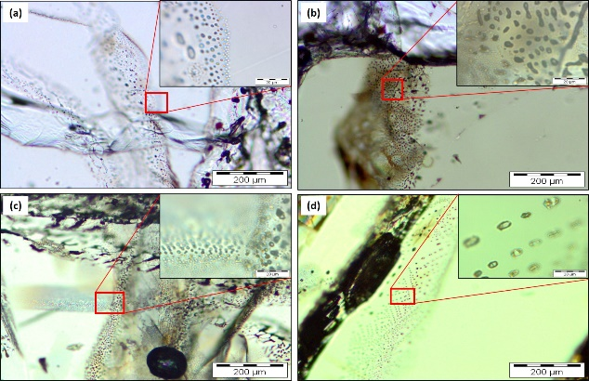Fig. 1: Plane-polarized light (PPL) photomicrographs of textures of FIs trapped in (a) olivine, (b) orthopyroxene, and (c,d) clinopyroxene.
REFERENCES:
Bodnar, R. J. (2003). Reequilibration of fluid inclusions. In I. Sampson, A. Anderson, & D. Marshall (Eds.), Fluid inclusions: Analysis and Interpretation (Vol. 32, pp. 213–230). Mineralogical Association of Canada.
Carnevale, G., Caracausi, A., Rotolo, S. G., Paternoster, M., & Zanon, V. (2022). New Inferences on Magma Dynamics in Melilitite-Carbonatite Volcanoes: The Case Study of Mt. Vulture (Southern Italy). Geophysical Research Letters, 49, e2022GL099075. https://doi.org/10.1029/2022GL099075

