COMPFLUX: a tool for the analysis of the effects of spurious sources and geometrical imperfections on the magnetic measurements in fusion devices
R.Fresaª, S. Minucci^{b}, A.Quercia^{b}, R. Albanese^{b},
ªCREATE/ENEA/Euratom Association, DIFA, Università degli Studi della Basilicata, Potenza, Italy
^{b}CREATE/ENEA/Euratom Association, DIETI, Università degli Studi di Napoli Federico II, Naples, Italy
E-mail contact: raffaele.fresa@unibas.it

Abstract –
In nuclear fusion devices there are several measurement systems, devoted to the evaluation of many physical quantities of interest for plasma confinement, like the energy confinement time, the poloidal beta, etc. Because of manufacturing and installation imperfections, the geometry of the real sensors differs from the ideality affecting the measurements they carry out, and the tolerable range for geometrical imperfections can be estimated by a sensitivity analysis.
The COMPFLUX electromagnetic numerical code allows to compute magnetic fields and fluxes generated by axisymmetric massive and general filamentary currents also in the presence of magnetized materials. It has been designed so as to carry out wide, accurate and fast sensitivity analyses. We show the main features of this suite with an example of application to the diamagnetic flux measurement in a fusion device.
Index Terms - Magnetic Field Calculation, Sensitivity analysis, Magnetic Measurements, Diamagnetic Flux.

Introduction
To enhance the performance of tokamaks it is necessary to measure some physical plasma parameters, i.e. poloidal beta, safety factor and confinement time.
For this purpose it is possible to use diagnostic systems, consisting of local sensors and coils deputed to measure the magnetic field along a prescribed direction and the magnetic fluxes linked with the coils themselves respectively; the field sources are the currents flowing in the active coils and in the passive structures of the machine, even in presence of ferromagnetic material.
The measurements carried out by the diagnostic system are affected by errors due to an imperfect matching of the real passive structures and the active coils with respect to the nominal design. To avoid degradation of the performance, a sensitivity analysis is necessary with respect to all error sources that could pollute the measurements.
The measurement can be also affected by imperfections of the sensor geometries that can consist in
- errors of positioning or alignment of the field sensors (i.e. the measurement performed by the real sensor differs from the nominal one because the magnetic field is computed in a different spatial point or along a different direction);
- rotations, shifts or random deformations of the flux sensors with respect to the nominal geometry (as the flux is computed by the path integral of the Vector Potential, it depends on the actual shape of the sensor itself).
These errors change dynamically during the operations because of thermal and electromechanical loads; thus, sensitivity analyses are necessary to know the tolerance limits of deviations of the sensor geometries with respect to the ideal case.
Of course, similar analyses should be carried out to investigate the allowed tolerance for the geometry of the active coils and passive structures.
The COMPFLUX code, main topic of this paper, has been designed, tested and validated with the aim to carry out a full and fast sensitivity analysis, also coupling it with different specialized electromagnetic codes, like CARIDDI or MISTIC.
Hereafter a summary of this article is provided.
In Section 2, the main characteristics of the COMPFLUX code are shown. The assessment of the suite is done in Section 3, by solving some test cases. In Section 4 a sensitivity analysis is performed on an example of interest for the applications: the diamagnetic measurement in a tokamak. Finally, in Section 5, the main conclusions are outlined and the efficiency of the code is discussed.

The COMPFLUX procedure
- General description
COMPFLUX is an electromagnetic code customized for the sensitivity analysis of diagnostic sensors of magnetic fields and fluxes.
The electromagnetic sources can be wires of any geometry and massive axisymmetric coils of rectangular section, each of them treated by a set of filamentary currents collocated in optimal way by using the Gauss points method. The computation of the magnetic field and vector potential is performed analytically by the Biot-Savart Law for both the kind of sources.
If saturated magnetic materials are present, they can be taken into account by partitioning them in spheres, in such a way that the total volume is kept (Fig.1a), and by computing the magnetization vector for each sphere.
The hypothesis of magnetic saturation allows to model each sphere as a magnetic dipole of assigned momentum and to superimpose the single contributions (Fig.1b) to obtain the total magnetic field and potential in the sensor positions.
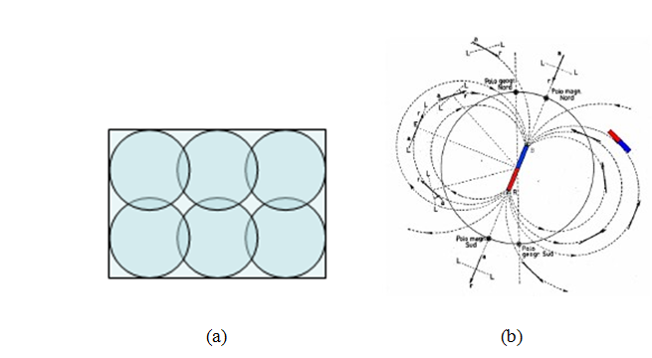
The scalar potential, the vector potential and the magnetic field associated to the magnetic dipole are respectively:
Fig. 1: a) Partitioning in spheres of the saturated materials.
b) Assimilation of a single sphere to a magnetic dipole.
;
The flux linked with a closed line γ is computed by the Simpson's rule: the line γ is divided in Nγ arcs evenly spaced and the line integral of the vector potential for each arc is approximated by the sum of three contributions as follows:
$$Φ_{γ}=\oint_{γ}{A⋅\hat{t}dl}=$$
$$=\sum_{j=1}^{N_{γ}}{\frac{A\left(x_{j0}\right)⋅dx_{j0}}{6}+\frac{2A\left(x_{j0.5}\right)⋅dx_{j0.5}}{3}+\frac{A\left(x_{j1}\right)⋅dx_{j1}}{6}}$$
The three points in the formula are the endpoints (0 is the starting point, 1 is the end point) and the middle-point (interpolated via spline, namely 0.5) of the interval [x_{j},x_{j+1}] while, according to parabolic approximation:
$$\begin{matrix}dx_{j,0.5}=x_{j+1}-x_{j}; \\ dx_{j,0}=-x_{j+1}+4x_{j+0.5}-3x_{j}; \\ dx_{j,1}=3x_{j+1}-4x_{j+0.5}-x_{j}; \end{matrix}$$

The COMPFLUX code allows to execute sensitivity analyses in case of perturbations of the field sensor position or of the trajectory of the flux sensor with respect to the nominal one.
These analyses usually require the knowledge of the vector potentials and fields in a large number of points and are very expensive in terms of CPU load, which can be dramatically decreased by computing the vector potential only in a set of points and recovering it in the remaining ones via interpolation. Essentially, the full map of the vector potential, in the nearness of the nominal curve of each flux sensor, is reconstructed by using an interpolation of the values computed for the sampled points of four auxiliary curves (see Fig.2). A third order interpolation without imposing constraints on the Laplacian of the vector potential provides better results with respect to a second order interpolation.
The same procedure is adopted for the reconstruction of the magnetic flux density in the region near the field sensor; in the latter case, the interpolation is carried out by using the evaluation of the fields in the six points surrounding the nominal sensor shown in Fig.3.

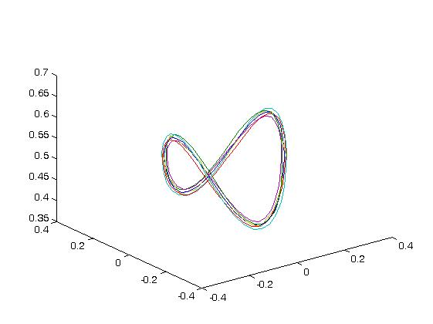
Fig. 2: The four auxiliary curves selected for the reconstruction of the potential map via interpolation.

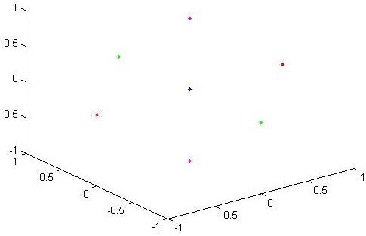.
Fig. 3: The six auxiliary points used for the reconstruction of the magnetic flux density in the space region surrounding a field sensor
In this way, sensitivity analyses for many set of perturbations of both flux and field sensors are executable with low computational cost because a single electromagnetic analysis (carried out by any processor: COMPFLUX, CARIDDI or MISTIC) can be used for a wide sensitivity analysis of the impact of diamagnetic loop deformation.

- Input sensors
In the Tokamak reactors many plasma physical quantities relevant for improving the quality of tokamak plasma discharge, like the confinement time of the plasma and the poloidal beta βp, can be measured by using magnetic sensors.
Magnetic diagnostics can be classified in several subsystems, as follows [1]:
- sets of pick-up coils, saddle and voltage loops mounted on the inner wall of the vacuum vessel;
- Rogowski coils mounted around earth straps of the blanket shield modules;
- sets of pickup coils, Rogowski coils and shunts mounted on the divertor diagnostic cassettes;
- sets of pick-up coils, loops and steady state sensors mounted on the outer surface of the vacuum vessel;
- continuous Rogowski loops mounted within the TF coil case.
Each sensor listed above can be modeled by one of the kind of sensors considered in the COMPFLUX code:
- punctual field sensor;
- filamentary flux sensors with rotational symmetry;
- 3D filamentary flux sensors.
The COMPFLUX preprocessor computes by sampling the output points associated to the sensors and to the auxiliary points and curves.
The distance between a flux (resp. field) sensor and the four (resp. six) associated auxiliary curves (resp. points) depends on the maximum spatial deviation assumed for the sensor itself.

- Field and flux computation
According to the nature of the sources, the flux density, B, and the magnetic vector potential, A, generated by the sources at the output points defined by the pre-processor are evaluated by three different processors can be used:
- the built-it procedure of COMPFLUX in Matlab
- the eddy current CARIDDI code in FORTRAN
- the error field oriented MISTIC code in Matlab

The COMPFLUX processor
The COMPFLUX [2] Matlab procedure is mainly oriented to the calculation of fields and potentials due to:
- axisymmetric coils
- 3D filamentary wires
- saturated magnetic materials
See the paragraph 2.1 above for further details.

The CARIDDI processor
CARIDDI [3-4], is a 3D integral code, well assessed to face numerically with the time-domain Maxwell equations in the magneto-quasi-stationary limit. In CARIDDI the electric vector potential T is adopted as unknown in such a way to automatically impose that the current density field, J, is divergence-free and its normal component is the continuous. Moreover, by using the edge elements for the numerical expansion of the electric vector potential, it’s possible to assume a numerical gauge based on the tree–cotree decomposition of the edges of the mesh retaining only the last ones as discrete unknowns. The final discretized model to be solved looks like the one of an Ohmic-inductive network
where:
;
;
and J_{C} is the impressed current density localized in the source domain Ω_{D}. Note that R is a symmetrical sparse matrix, whose elements R_{i,j} do not vanish only if the i-th and j-th unknowns share the same mesh element. On the other hand, L is a symmetric full matrix because the L_{i,j} coefficients keep in account the long-distance interactions between the unknowns.
The CARIDDI (linear eddy currents) and its non-linear version, CARIDDI-MAG [5], codes would be able to directly calculate the magnetic flux linked with a diamagnetic loop via time integration of the electromotive force; however, this would be expensive not only for the time integration itself, but also due to the need of providing a solid model (i.e., a mesh) of the loop. Therefore, the flux can be computed by COMPFLUX using the line integration of the magnetic vector potential, as described in Section 2.1. Thus, the task of these processors is to calculate magnetic field B and magnetic vector potential A produced by the sources at the output points defined by the COMPFLUX pre-processor.

The MISTIC processor
MISTIC [6] is an EM code aimed to compute magnetic field maps generated by coils of arbitrary shape. The code is based on the analytical expression of flux density and vector potential for elementary current sources represented by “current sticks”. The massive coil of arbitrary shape is subdivided in a suitable number of sticks, and superposition principle is used to compute the required output in the prescribed set of field points.

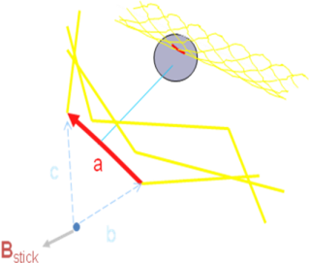
Fig. 4: The flux density due to the a current stick.

With reference to Fig. 4, the core formulas for the Flux density and the Vector potential are respectively:

The code was originally designed to assess the impact of manufacturing and assembly tolerances in the thermo-nuclear fusion reactors field coils, and this implies that the shapes of arbitrary coils that MISTIC considers are basically deformations of poloidal and toroidal coils. In addition, since two kinds of analysis were originally foreseen, namely statistical analysis of the tolerance impact and single deformation analysis, the main input data about coils are their nominal geometry, the deformation ranges for the statistical analysis, and the set of specific values for the single case analysis.

Test cases
- Flux computation in 2D axisymmetric geometry in presence of magnetic material
As first test case to assess the accuracy of COMPFLUX, we consider the axisymmetric configuration reported in fig.5 consisting of one coil with an uniformly distributed 100 A current and a linear magnetized (μ_{r}=10) material ring.
We compute the total flux in three different points, both in air and in presence of the magnetic material with several codes:
- SOLENOID (an analytical code based on the elliptical integrals) [7];
- the FEM commercial code COMSOL Multiphysics [8];
- the COMPFLUX code;
- the MISTIC code;
- the 3D integral code Cariddi.

The magnetic ring is modeled by (nr=2)x(nz=8)x(n_{φ}=90) magnetic spheres and the magnetization vector, prescribed to each sphere, is obtained by COMSOL.
Results are reported in the following tables 1 and 2:

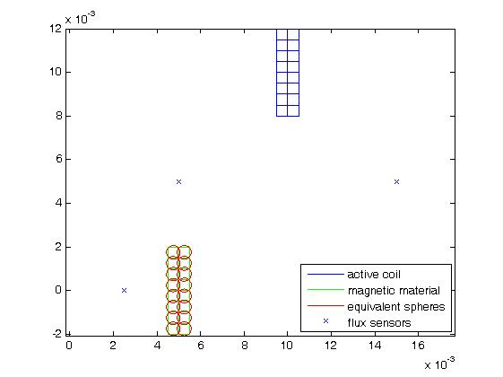
Fig. 5: Test case n.1 - the 2D axisymmetric geometry

Table 1: Test case n.1 - Results in absence of magnetic materials (Total flux in air)
r [m] | 5.0e-3 | 1.5e-2 | 2.5e-3
z [m] | 5.0e-3 | 5.0e-3 | 0.0e+0
SOLENOID [Vs] | 3.5170e-7 | 1.1882e-6 | 4.3480e-8
COMSOL [Vs] | 3.5170e-7 | 1.1882e-6 | 4.3481e-8
COMPFLUX [Vs] | 3.5171e-7 | 1.1879e-6 | 4.3478e-8
CARIDDI [Vs] | 3.5173e-7 | 1.1860e-6 | 4.3432e-8
MISTIC [Vs] | 3.5170e-7 | 1.1879e-6 | 4.3477e-8

Table 2: Test case n.1 - Results in presence of magnetic materials (Total flux in presence of magnetic material)
r [m] | 5.0e-3 | 1.5e-2 | 2.5e-3
z [m] | 5.0e-3 | 5.0e-3 | 0.0e+0
COMSOL [Vs] | 3.6685e-7 | 1.2114e-6 | 3.3654e-8
COMPFLUX [Vs] | 3.6657e-7 | 1.2111e-6 | 3.3706e-8
CARIDDI [Vs] | 3.6645e-7 | 1.2089e-6 | 3.3740e-8

- Flux computation in 3D geometry
As second test case we considered the problem proposed in [9], whose geometry is illustrated in Fig. 6. The aim is the evaluation of the flux linked with the central wire.
The side of each hexagonal wire is 20 cm, located at 25 cm from each other, and each hexagon side has been interpolated with 40 pts.
Fig. 6: Test case n. 2 - Flux computation in 3D geometry
The calculations with the three different processors yield the following values of the flux:
- COMPFLUX processor: 0.0536646 Vs;
- CARIDDI processor: 0.0536630 Vs;
- MISTIC processor: 0.0536618 Vs;
while, according to Grover, the analytical value of the flux linked with the central wire is 0.05367 Vs.

- Flux linked with a diamagnetic loop due to PF/TF coils and magnetic inserts
The next test case consists in the computation of the magnetic flux linked with a diamagnetic loop [1] (see Fig.7). Diamagnetic flux measurement systems are used in fusion reactors for a precise evaluation of the energy confinement time, poloidal beta and other MHD parameters. The computation of the flux linked with them is a full 3D geometry problem and must be carried out, for some reactors, in presence of magnetic material.

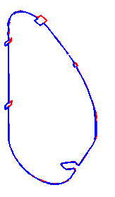
Fig. 7: Test case 3 – Diamagnetic loop
In this test case we simulate a realistic situation by considering both poloidal and toroidal field sources with the additional presence of ferromagnetic inserts (Fig.8).

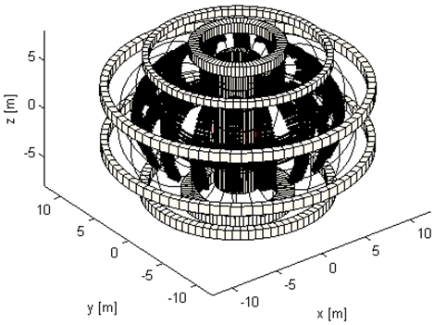
Fig. 8: Test case 3 - Flux linked with a diamagnetic loop due to PF/TF coils and magnetic inserts
The results, obtained by using both CARIDDI-MAG and COMPFLUX processors, are reported below:

- CARIDDI-MAG processor: 262.7309 Vs;
- COMPFLUX processor: 262.7295 Vs

In the latter, we model the ferromagnetic inserts by a set of spheres, as described in the paragraph 2.1 using CARIDDI for the computation of the magnetization vector field of the inserts.
The flux computed by the two processors is the sum of the three contributions due to TF Coils, PF Coils and Ferromagnetic Inserts; the following table 3 summarizes the single contributions for each calculation.

Table 3: Test case n.3 – Single contributions of the sources to the flux linked to the diamagnetic loop
 | COMPFLUX | CARIDDI
TF Coils Flux [Vs] | 262.1319 | 262.1359
PF Coils Flux [Vs] | 1.115e-16 | 0
Ferromagnetic Inserts Flux [Vs] | 0.5975 Vs | 0.5950

- Deformation of a loop
The last test case is devoted to assess the performance of the interpolation procedure for the flux computation.
The source is a circular wire of 1 m radius, located at z = 0 and carrying an 1 A current; the unperturbed magnetic sensor is a coaxial loop of the same radius, located at z = 0.5 m, which is then perturbed by a rigid deformation (we first apply a translation of Δx = 0.02 m, Δy = 0.02 m, Δz = 0.01 m; then a rotation of 4 deg around the x-axis) (Fig.9).
An unperturbed flux of 1.1126E-06 Vs is obtained both via COMPFLUX and SOLENOID codes.
The perturbed flux, directly computed by the COMPFLUX processor, is 1.0957E-06, while the perturbed flux calculated via interpolation is 1.0964E-06 Vs.
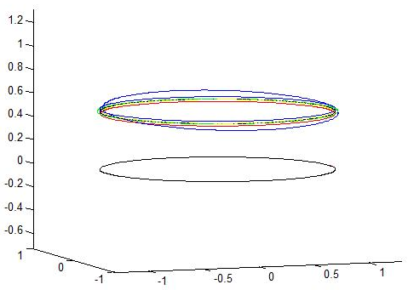
Fig. 9: Test case 4 - Deformation of a loop. The four auxiliary curves used for the interpolation are shown as well as the deformed curve (blue curve)

Conclusions
In this paper we have presented COMPFLUX, a tool for the analysis of the effects of spurious sources and geometrical imperfections on the magnetic measurements in fusion devices.
The sources are massive axi-symmetric coils, generic filamentary wires, and ferromagnetic materials with known magnetization, (e.g., in the presence of saturation).
An interpolation procedure, based on the pre-computation of the magnetic field and vector potential at a set of points (auxiliary sensors related to the nominal ones), allows to carry out extensive and fast sensitivity analyses in the presence of error sources and sensor deformations. These input quantities can be prescribed taking into account both deterministic and statistical considerations.
The code, validated for several test cases, performs in a satisfactory way. The order of magnitude of the accuracy is about 10 ppm, fulfilling the usual requirements for the measurement systems of the fusion devices.

Acknowledgements

The authors are grateful to Profs. A. Formisano, G. Rubinacci and F. Villone for their useful suggestions.

References
- R. Fresa, R. Albanese, S. Arshad, E. Coccorese, M. De Magistris, S. Minucci, A. Pironti, A. Quercia, G. Rubinacci, G. Vayakis , F. Villone “Sensitivity of the diamagnetic sensor measurements of ITER to error sources and their compensation”, submitted for publication on IEEE Trans. on Instrumentation and Measurement
- R. Albanese, R. Fresa, "D2.7: Diamagnetic flux computer model and demonstration case, including any input files, output files and any source code developed", Technical Report on F4E Grant No. F4E-2009-GRT-047(PMS-DG) CREATE_047_D2.7-D2.10_7_v_d003, F4E UID= 24LF7R, v.1.0, September 2011
- R. Albanese and G. Rubinacci. “Integral formulation for 3D eddy current computation using edge-elements”, IEE Proceedings, vol.135 Part A, pp. 457– 462, 1988.
- R. Fresa, G. Rubinacci and S. Ventre, “An eddy current integral formulation on parallel computer systems”. Int. J. Numer. Meth. Eng., vol.62, pp. 1127-1147, 2005.
- R.Albanese, G.Artaserse, T. Bellizio, G. Rubinacci, R. Fresa, B. Viola, M. Furno Palumbo, F. Villone, Y. Liu, “Coupling plasmas and 3D passive structures in the JET tokamak”, International Journal of Applied Electromagnetics and Mechanics 33, pp. 533–540, 2010
- J. Knaster et al., "ITER non-axisymmetric error fields induced by its magnet system", Fusion Engineering and Design 86 (2011) 1053–1056.
- R. Albanese, R. Fresa, R. Martone, “Accurate computation of electromagnetic fields in the presence of conducting and magnetic materials”, International journal of applied electromagnetics in materials, Vol.6, n. 1, pp. 73-88, 1995
- http://www.COMSOL.com/
- Grover,”Calculation of mutual inductance and self-inductance”, Chapter 9, example 21, pp. 66-69

[10] R. Albanese, L. Barbato, R. Fresa, S. Mastrostefano, G. Rubinacci, S. Ventre and F. Villone, “Effect of 3D Ferromagnetic Materials on
Plasma Nonlinear Evolution in Fusion Devices”, submitted for presentation to the Sixteenth Biennal IEEE Conference on Electromagnetic Field Computation (CEFC), Annecy, France, May 25-28, 2014

