Os sistemas de informação geográfica (SIG) como ferramenta de optimização da exploração florestal em regiões de montanha

Giovanni Pecora¹, Nicola Moretti^{1,} Susana Saraiva Dias², Orlanda Póvoa²
¹University of Basilicata - SAFE School of Agriculture, Forestry, Food and Environmental Sciences , Viale Dell’Ateneo Lucano, 10; 85100 Potenza, Italia, email: giov.pecora@gmail.com
²Escola Superior Agrária de Elvas do Instituto Politécnico de Portalegre, Edifício Do Trem Auto, Avenida 14 De Janeiro, 7350-903 Elvas, Portugal

Resumo
O software ArcGIS foi utilizado para a planificação da extração de madeira em cinco (5) florestas de folhosas de montanha da região de Basilicata, Sul de Itália.
Nos modelos foram consideradas as características orográficas dos locais, tais como o declive, a rede hidrográfica e outros obstáculos naturais do relevo. Os dados de volume de madeira foram baseados nos planos de ordenamento florestal locais, assim como em dados de campo oriundos de um inventário piloto. Também foram introduzidos os diferentes métodos de extração e concentração de madeira utilizados pelas empresas florestais locais; assim como as diferentes tipologias de estradas e caminhos de acesso às florestas.
A análise efectuada permitiu identificar áreas florestais com diferentes níveis de acessibilidade e restrições orográficas, o planeamento de caminhos de acesso adicionais necessários à optimização da exploração florestal; assim como a optimização local-a-local dos métodos de extração de madeira e das intensidades de corte periódicas. Esta metodologia de análise deve ser testada noutras regiões florestais de montanha.
Palavras-chave: Exploração-florestal, Acessibilidade-florestal; rede-acessos-florestais.

Geographic information systems (GIS) as a tool for the optimization of timber harvesting in mountain regions forests.

Abstract
ArcGIS software was used for timber harvesting planning in five (5) different mountainous broadleaf forest areas from Basilicata region, located in South Italy.
Orographic characteristics, such as slope, watershed systems features and other natural obstacles were considered. Data for timber volume predictions were based on local forest management plans and also on a pilot field inventory. The different manual and mechanical timber extraction and concentration methods used by local timber companies were also considered. The different typologies of roads network to access forests were also introduced in the models.
The analysis allowed identifying forest areas with different accessibilities and orographic restrictions, the planning of additional roads necessary for timber extraction optimization, as well as optimized site-by-site timber extraction methods and periodic cutting intensities. This methodological approach should be tested in other mountainous forest regions.
Key–words: Timber harvest, GIS, Forest profitability, Forest accessibility
Introduction
The GIS is a software technology that allows you to locate and analyze objects and events that occur on the earth, while the Italian SIT (Territorial information system) is a set of hardware technology components, software and human resources capable to process, store, analyze and integrate spatial data to produce information for the government and management of the territory (Masoni et al.,2005).
There are various software technologies used based on GIS, as well as experiences within forestry sciences based on the management of digital territorial data (Pira and De Natale1999) that were used to access road infrastructure network in the forest (Scrinzi et al. 1999). Increasingly, the SIT have been used to identify forest areas subject to avalanche phenomena or forest fires based essentially on the evaluation of the land characteristics and forest coverage (Ciolli et al., 1998, Ciolli et al. 1999a).
By combining and analyzing information from orographic type, infrastructure network and forest coverage, cartographic models of analysis can be processed aimed to identify, site by site in the forest, the labor instruments and the work systems more rational in relationship to the land conformation and the network road features.
This paper has as main goal to optimize the forest harvesting in European mountainous areas with the aid of geographic information systems GIS. This approach was developed for the harvesting planning and timber concentration within five forested areas in the province of Potenza, Basilicata region, Italy.
Materials and methods
The five studied forest areas are Regional Forests:belonging to the province of Potenza, Basilicata region in Italy: Bosco Grande Forest, Grancia Forest, Fossa Cupa Forest, Lata Forest, and Rifreddo Forest.
In the forest utilization planning, the factors that define the choice of forest machines and labour instruments are mainly the road network, land features (slope and accessibility), timber dimensions and, harvesting operations (harvesting systems and timber concentration systems).
Roads network analysis
In the present study, it was proposed the development of a methodology to support the assessment of “timber harvesting road”, in five different area of the Lucano Apennines, based on the determination of the uses in forested land and the determination of the wooded land served by roads.
Two shape files have been created for the determination of the roads already present in the forests, and the missing roads to be constructed, and were classified according to the classification of Hippoliti (1994) as: main roads for truck, secondary roads for truck and roads for tractors or tracks. The first shape file was made by digitizing roads present in the forest, using a map IGM 1:25.000, traffic layer of the Environment Italian Ministry and Ortophoto of Basilicata region. Each road was classified according to the geometric features of Hippoliti classification such as minimum, maximum and average width, average and maximum slope, and curvature radius, which were recorded in Arcgis 10, ESRI (2011), attribute table, as shown in Figure 1.
The second shape file was built by digitizing along the contour lines, with 25 meters distance, constructed from DEM (Digital Elevation Model), with 20 meters resolution. New roads have been digitized, starting from the intersection of the contour layer and the existing roads layer, taking into account spatial constraints, such as hydrographic network, steep slopes, hydrogeological risk, like shown in Figure 1.
The new road network system was only considered were the timber extraction was economically possible. The amount of extractable timber, according to the forest management plans, has to be sufficient to compensate the costs for new road construction.
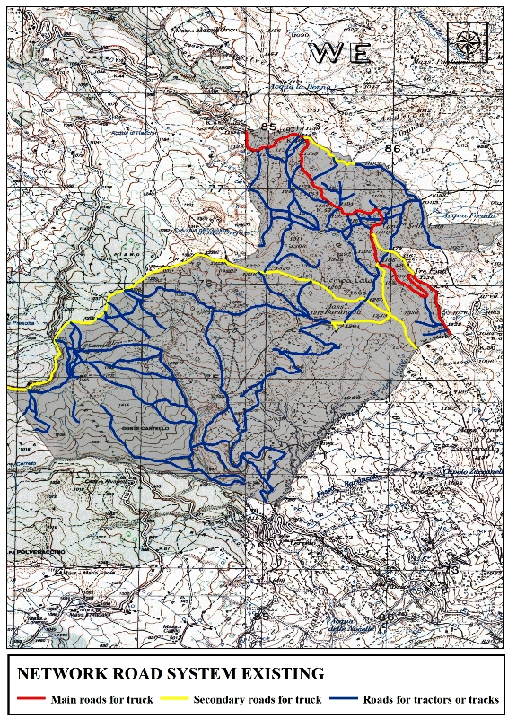 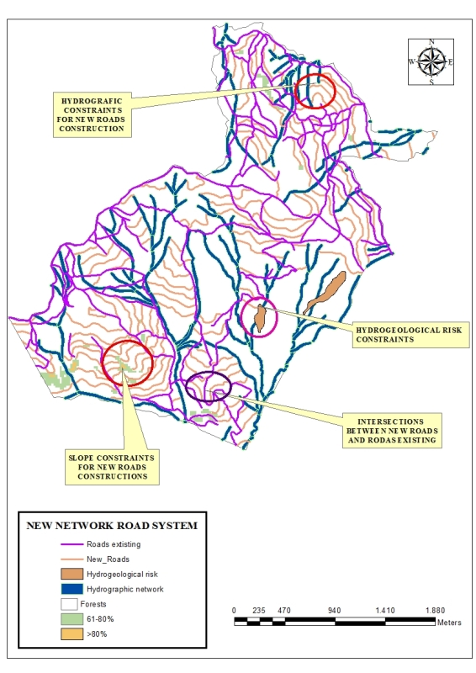Figure 1-Example of existing roads network (left) and new road system to be constructed (right) in Lata forest.
Slope analysis
The slope analysis was performed using the DEM, which has been processed with the Spatial Analyst Tool "Slope", and was then reclassified as percentage considering five classes according to Hippoliti (1994): 0-20%, 21-40%, 41-60%, 61-81% and > 80%. The high gradients influenced the new roads construction in forests, in fact land slopes above 60% were not considered for road construction, thus influencing the choice of timber harvesting and concentration systems.
Timber volume
The timber volume was based on regional forest management plans. A pilot inventory was done considering six sampling plots for each of the 5 forests, which confirmed the timber data from forest management plans. In result, these forests have been subjected to low cutting intensities (low thinning and phytosanitary cuttings), according to the cutting intensity classification of Hippoliti (1994), which provide a timber extraction up to 30 cubic meters per hectare for each extraction cycle.
The trees diameter were very variable, depending on tree species and site conditions; usually the trees to be cut are chosen by a technician from regional forest, then marked, recorded, and in the end cut by the forest regional workers. This timber was used just for firewood, Basilicata region government (2004).
Timber concentration and harvesting systems
The scheme proposed by Hippoliti (1994) takes into account several parameters, including slope classes, concentration system, cutting intensity, harvesting direction, timber dimensions, harvesting system. This was applied only in forests well served with roads, because the timber extraction cost was considered too high in areas without accessibility.
Results and discussions
The results obtained from the spatial analysis showed that the presence of roads in the forests in some areas was very poor. With the methodology proposed there was a significant percentage increase of new roads, and therefore a good increase of forest accessibility. In fact, the percentage increase of new roads on total was as follows: Bosco Grande Forest 56%, 48% Fossa Cupa Forest, Forest Grancia 63%, Lata Forest 49%, Forest Rifreddo 30%. The limited roads amount in some areas is due to the presence of territorial constraints, such as the hydrographic network, hydrogeological risk and steep slopes. The new road construction has allowed the increase of the road density, making forests more accessible. Adequate primary and secondary roads and trails should be planned with respect to density, routeing and other physical characteristics such as width, slope and presence of suitable landings (Baldini et al, 2008). However, due to regional legislative constraints, we only proposed secondary roads or roads for tractors, and logically it is not advisable to build major roads in the forest already established. As shown in table 1.
Table 1: Proposal of new road construction intensity in 5 forests of Basilicata region.
New road construction influence
Forest |  | Secondary road for truck |  |  |  | Road for tractors or track |  |  |  | Tot/Road
 |  |  | before | after | tot |  | before | after | tot
Name | ha | m | m/ha | m/ha | m/ha | m | m/ha | m/ha | m/ha | m
Bosco Grande | 472 | 9431 | 2 | 20 | 22 | 12011 | 34 | 25 | 59 | 21442
Fossa Cupa | 746 | 8533 | 12 | 11,4 | 23,4 | 22147 | 32 | 30 | 62 | 30608
Grancia | 456 | 9536 | 5 | 21 | 26 | 17047 | 29 | 37 | 66 | 26583
Lata | 755 | 10913 | 9 | 14,5 | 23,5 | 29695 | 46 | 39 | 85 | 40608
Rifreddo | 173 | 1645 | 11 | 9 | 20 | 3066 | 49 | 17 | 66 | 4711
Table 1 shows as the new road construction has influenced the road density, especially the road for tractors or tracks. There have been considerable improvements of roads in the Grancia forest, much less in the Rifreddo forest, this difference was due to the strong hydrogeological risk presence on the territory of Rifreddo forest. The choice for different roads was carried out considering the existing roads, and it was decided to build secondary roads where they were not present, connecting to previous secondary roads.
The choice of concentration and harvesting systems are resumed below in Figures 2 and 3. In result, low cutting intensity were applied concerning timber diameter range from 17.5 cm to 24.0 cm, sometimes the diameter could be higher for some tree species and site conditions.
Figure 2 - Concentration systems in function to the slope class and ground slope.
Figure 3 - Harvesting systems in function to the slope class and ground slop.

Hand-skidding, lightweight tractors with trailer, with basket or winch, drag with winches or with animals, are common systems used for timber concentration and harvesting in Basilicata region, these systems are used both downhill and uphill. Sometimes the forest companies used chute cut in half system, particular the system that consist of half chutes joined end-to-end to form a continuous channel guiding the timber down a slope. The cable crane system could be used within the two classes with high slope where the forests are served by roads, however on these high slopes all systems are usually uneconomic.
Conclusion
The proposed model has the goal to provide guidelines for the effective mechanization of forest harvesting and timber collection, directing the choice to the most suitable systems for different territorial conditions, in order to optimize the work of forest companies, using GIS tools.
The GIS spatial analysis could be a tool for the improvement and development of “woodcutter profession” still underdeveloped in the Basilicata region.
Bibliography
Baldini, S., Cavalli, R., Piegai, F., Spinelli, R., Di Fulvio, F., Fabiano, F., Grigolato, S., Laudati, G., Magagnotti, N., Nati, C., Picchio R., (2009). Prospettive di evoluzione nel settore delle utilizzazioni forestali e dell'approvvigionamento del legname. Atti del Terzo Congresso Nazionale di Selvicoltura. Taormina (ME), 16-19 ottobre 2008. Accademia Italiana di Scienze Forestali, Firenze, p. 717-728.
Ciolli, M., Tabarelli, S., Zatelli, P. (1998). 3D spatial data integration for avalanche risk management. In: International symposium on GIS: “Between Visions and Applications”. Stuttgart, International archives of photogrammetry and remote sensing 31 (4): 121-127.
Ciolli, M., Mascarell, P., Sguerso, D., Zatelli P. (1999a). Valutazione tramite fotogrammetria e GIS della dinamica della copertura forestale e della provvigione legnosa. In: Atti della 3° Conferenza nazionale delle Associazioni Scientifiche per le informazioni Territoriali ed Ambientali, Napoli 1: 589-594.
ESRI, (2011). ArcGIS Desktop: Release 10. Redlands, CA: Environmental Systems Research Institute.
INEA (2004). Forest management plan, Environment Italian Ministry, Basilicata region government, INEA, Forestry police.
Hippoliti G. (1994). Le utilizzazioni forestali. Editrice CUSL, Firenze. pp 19-20, 85-89,92-96,
Masoni, M., Dibari, C., Siddi, E. (2005). I Sistemi Informativi Territoriali. Provincia di Pisa. [online] URL: http://sit.provincia. pisa.it/sisterims/html/Corso_SIT/Corso_pagina_iniziale. Htm
Pira, G., De Natale, F. (1999). La gestione dei dati digitali territoriali nell’attività forestale. Alcune esperienze di programmazione come integrazione nell’uso dei GIS. Dendronatura 2/99, Associazione Forestale del Trentino, Trento. pp. 34-37.
Scrinzi, G., Picci, M., Floris A. (1999). Analisi in ambiente GIS per la valutazione del grado di infrastrutturazione viaria delle aree forestali. Dendronatura 2/99, Associazione Forestale del Trentino, Trento, pp. 63-73.

